**[Security and Networking Opportunities in the Public Sector]**

**Security and Networking Opportunities in the Public Sector***By:**M.K. Fisher, Manager, Partner Enablement Management, TD SYNNEX*

State, local government and education season – otherwise known as “SLED season” – is upon us, and the TD SYNNEX team wants to ensure you’re prepared with the knowledge you need!

**June 30** is the most common fiscal year end for SLED organizations. Every year, a large number of new bids – also known as requests for proposals, —or “RFPs” – will be awarded during Q4 (between April 1-June 30). Being equipped with the latest security and networking knowledge will help you win these opportunities.

We are seeing historic levels of IT spend in SLED with projected state and local at $137 billion in 2023.1 Diving into the focus of this spend, solutions for broadband, cybersecurity, infrastructure, education and technology modernization are seeing the most growth. This should be no surprise, as cybersecurity is the number one priority for today’s state, count, and city CIOs.

This historical growth is mainly due to rising market concerns and end user needs. But public sector organizations in SLED are also receiving lots of new funding this year, or have funding that has not been spent yet, creating additional IT demand over the next three years.1

As a TD SYNNEX reseller customer, you have full access to three catalog contracts with TD SYNNNEX Public Sector: NCPA, OMNIA and Equalis. Plus, our security and networking solutions are supported across all fifty states. Take advantage of TD SYNNEX’s bid and RFP resources today and reach out to our team at [CyberPublicSector@tdsynnex.com](mailto:CyberPublicSector@tdsynnex.com) to learn more on how you can win SLED business.

**Note:** Please add this chart (or re-create if quality is not good enough) into the bottom of the article as a reference:

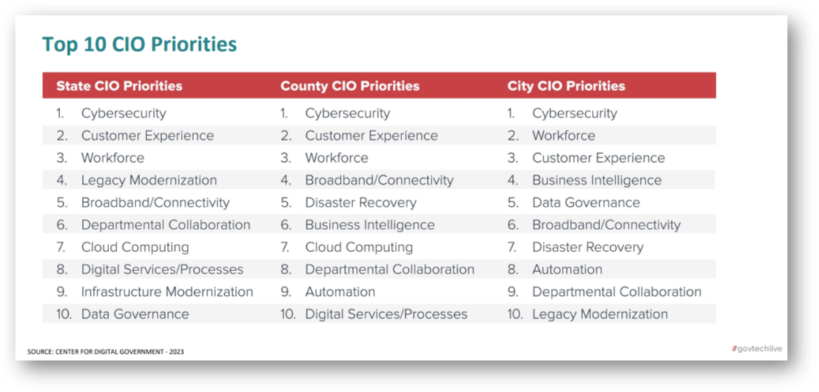

**[Footnote]** 1. eRepublic Navigator Insights