StreamOne Enterprise Solutions Cloud Platform for Customers

Tech Data StreamOne Enterprise Solutions cloud platform is tightly integrated with top cloud providers, and our services are available through a network of channel partners who are committed to delivering cloud solutions at the highest level of customer service. Together, Tech Data Cloud and our valued partners offer the most advanced products in today’s market, along with best-in-class service and support.

StreamOne Enterprise Solutions
Tech Data Cloud provides the best combination of leading Infrastructure as a Service (IaaS) Cloud Providers with multi-cloud services management capabilities and tailored support all powered by StreamOne Enterprise Solutions (SES) cloud platform. The authorized Channel Partner will work with you to meet your cloud strategy needs and enable you to leverage the unique capabilities of the SES cloud platform including:
- Simplify management of multiple cloud providers using a single cloud platform that enables efficient purchasing and provisioning directly with each cloud provider.
- Proactively manage cloud consumption across the enterprise with dashboards, drill-down reports and trending analyses that can be viewed by any number of authorized staff.
- Take advantage of cost optimization and security best practices* with the recommendations provided by the analytics reporting capabilities.
- Automate charge-backs with configurable cost management features such as tagging of resources and price book access to determine costs to allocate by group.
- Manage accountability and governance with built-in approval based workflows and customized templates across multiple cloud provider services.

Simplify Multi-Cloud Provider Management
Tech Data and our resellers enable customers to procure cloud services from a single source accessing a full range of industry-leading IaaS cloud providers that can be managed together for greater efficiency. Included are Amazon Web Services, Microsoft Azure, IBM SoftLayer/Bluemix and many others. Unlike other cloud platforms that lack a direct connection to the cloud provider, with SES you are able to:
- Retain full control of your accounts and all dashboard information
- Access to all cloud provider services along with their unique features
- Discontinue use of StreamOne Enterprise without service impact

* Security optimization analysis is currently available for Amazon Web Services.

Proactively Manage Consumption and Automate Charge-Backs
SES makes it easier for you to improve oversight and control of departmental cloud spends along with automating department charge backs. With access to a powerful dashboard and analytics, you are able to:
  - Monitor all associated cloud services usage through intuitive dashboards and customizable drill-down reports
  - Organize and track costs by product category, resource IDs and defined cost centers
  - Improve accuracy with assignment and management of charge-back costs
  - Access granular usage details down to the hour and monitor and report on associated usage history in familiar billing formats
  - Gain transparency with a multi-tier view of relevant usage and cost information

Optimize Cloud Spend and Security
Optimize cloud spend with cloud provider specific reporting and recommendations. Take advantage of detailed billing history and analytics reporting, working from actual billing data and both current and historical demand to receive recommendations with greater accuracy. The robust analytics reports enable you to reduce cloud account sprawl throughout the organization by allowing you to:
  - Track all actual (not estimated) usage charges across every major product category
  - Take advantage of compute and storage volume tiers
  - Optimize costs with detailed analytics and intelligent recommendations
  - Improve security posture with recommendations on best practices to implement*

© 2017 Tech Data Corporation
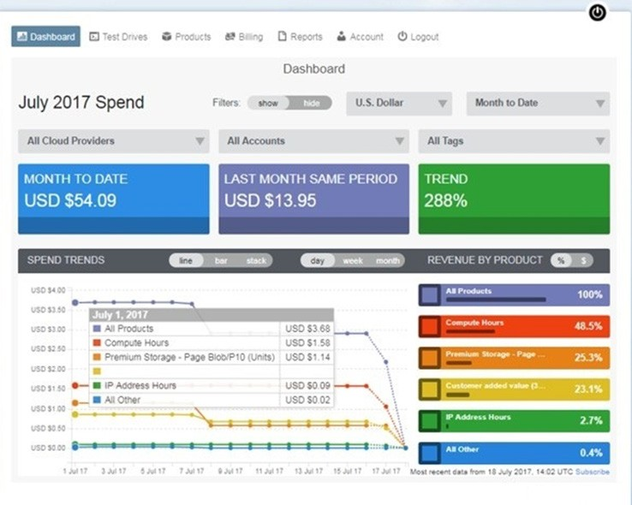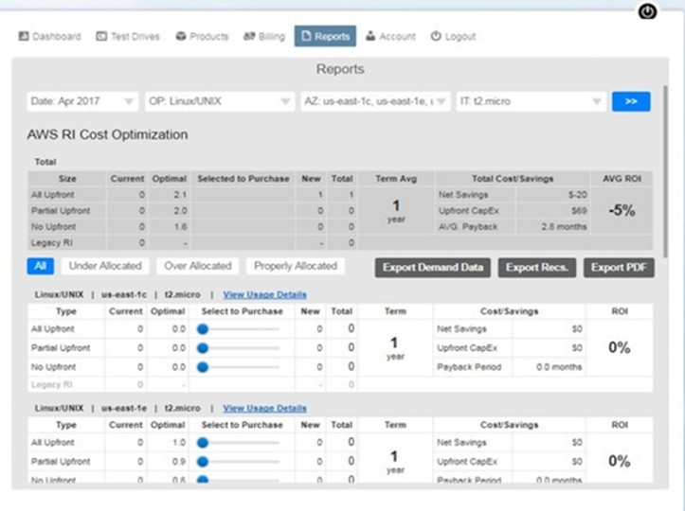

Manage Accountability and Governance
SES provides the visibility you need into all consolidated cloud accounts and their owners. In addition, the self-service portal even allows you to address concerns around management processes and governance requirements of your public cloud infrastructure.

To learn more about the products and services available through our partner network contact us at XXXXX and we will connect you with one of our channel partners to get you started.
With SES, you can:
  - Automatically provision infrastructure environments using the test drive feature to define user access, manage environment uptime, and attach environment-specific documentation such as test scripts, operations guides and instructional videos
  - Access built-in approval based workflows with custom templates
  - Simplify provisioning of new accounts and link existing accounts into one consolidated bill
  - Extend access to the self-service portal for provisioning and the visibility needed at various levels within your organization.
  - View real-time reporting on usage and costs
  - Request permissions and functionality to link existing accounts or provision new ones

